# About

This walkthrough will guide you in order to use the UMA’s Resource Agent Android application.

# Resource Agent Application

This application acts as a device and network monitoring application on Android devices. The application can be used directly from the user interface or remotely, making it ideal for automatic testing.

# Usage

The application can be used on the terminal with the provided user interface, or remotely through adb commands.

## Adb commands

The application can be used remotely sending intents to the service via the startservice command of adb:

adb shell am startservice -n com.uma.resourceAgent/.ResourceAgentService

The application accepts the following intents (-a):

com.uma.resourceAgent.START

com.uma.resourceAgent.STOP

**EXAMPLES**

adb shell am startservice –n com.uma.resourceAgent/.ResourceAgentService –a com.uma.resourceAgent.START

adb shell am startservice -n com.uma.resourceAgent/.ResourceAgentService -a com.uma.resourceAgent.STOP

## Device Interface

The application can be used through the device interface. The application is divided into two parts. The first one monitors the **network** interface: Operator, Network, Cell ID, LAC, RSSI, PSC, RSRP, SNR, CQI and RSRQ. The second one is used for monitoring the **device** information: CPU usage; Ram used and available; packets received and transmitted; and bytes transmitted and received.

The network section (1) is updated with every network change and the device information (3) will be updating one the user presses the button Start (2) and it will take between one and three seconds to update, depending on the device.

Once the device monitoring is initiated, the Log (3) will be updated during the execution.

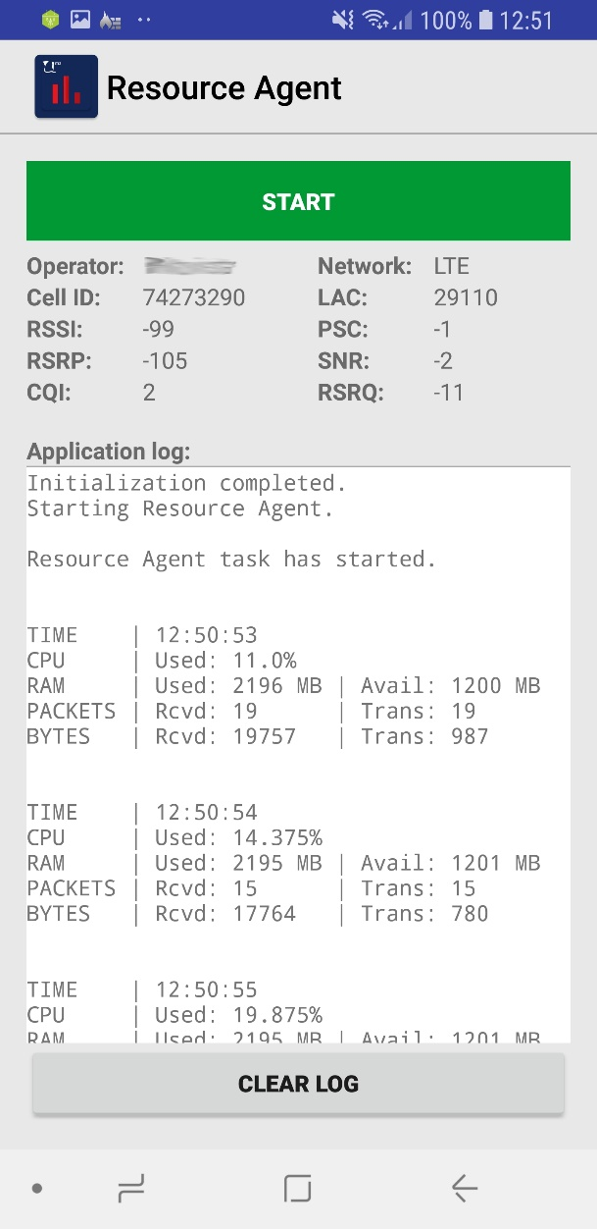

**3**

**1**

**2**

Figure 1: Application Interface